Topic Assignment # 2 – Liberal, Conservative or Centrist?
Tasks:
1) Do you think you are a liberal, conservative or centrist? __________________________________

2) Take the “Typology” test online (Do your best to answer as accurately as possible)
http://www.people-press.org/quiz/political-typology/

What is your best fit? ________________________________________________________________

Summarize what that typology means:

Do you agree with your characterization? Why or why not?

3) Take the “Are you liberal or conservative?” test online
https://www.proprofs.com/quiz-school/story.php?title=are-you-liberal-conservative

What did you get? ________________________________________________________________
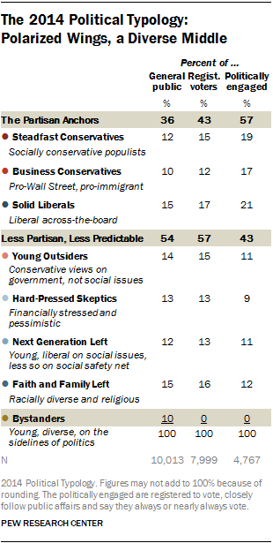
Summarize what that identification means:

Do you agree with your characterization? Why or why not?

3) Take the “The Enhanced-Precision Political Quiz” test online
http://www.quiz2d.com/quiz/

What did you get? ___________________________________________________________________

Summarize what that means:

Do you agree with your characterization? Why or why not?

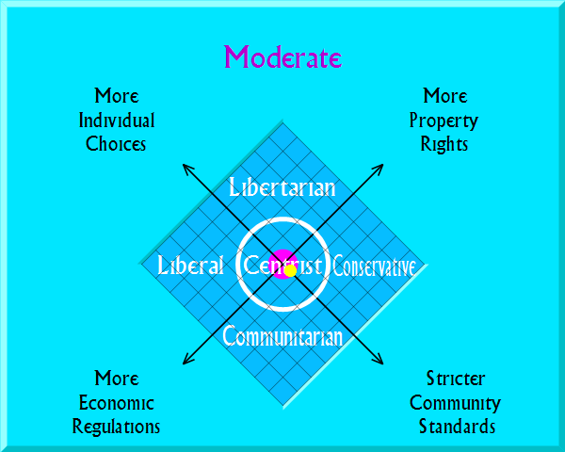

4) Overall, are your results consistent?

5) Are your results what you thought they would be? Why or why not?

