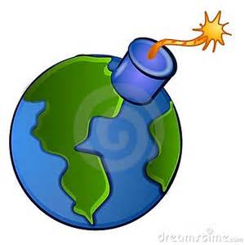

***What caused RISING TENSION in Europe that led to an outbreak of war?***

**World War One**

Name: ________________________

**Militarism**:

Examples of Militarism

1)

2)

How did **militarism** create tension in Europe?

**Alliances**:

Triple Alliance: Triple Entente:

1) 1)

2) 2)

3) 3)

How did **alliances** create tension in Europe?

**What was the SPARK that set off World War I?**

Examples of Nationalism

1)

2)

How did **nationalism** create tension in Europe?

**Nationalism**:

Examples of Imperialism

1)

2)

3)

How did **imperialism** create tension in Europe?

**Imperialism**: