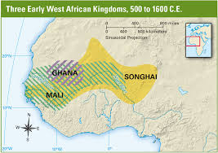 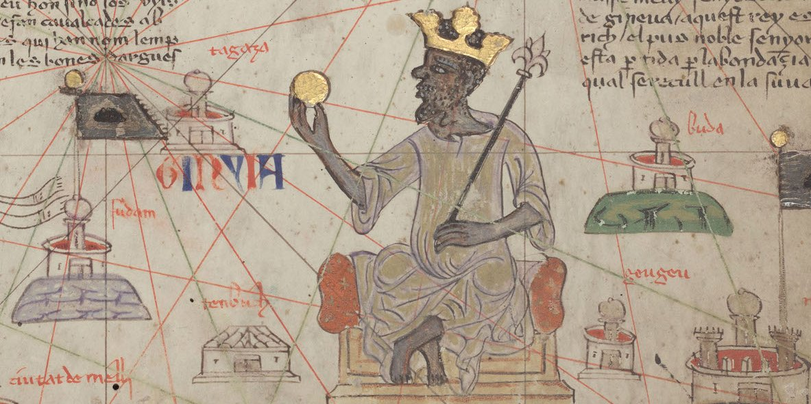

The Wealthy and Powerful kingdom of Mali ruled West Africa after Ghana.

__________________ made Mali into an Empire and _________________________ led a GOLDEN AGE. Mali is one of the richest Kingdoms in World History.

Mansa:

In Mali ______________________ was one of the most advanced cities in the world.

**The Kingdom of Mali**

**Invasion**:

**Overgrazing**:

**Internal rebellion**:

**THE FALL of GHANA**

Located in _______________________ on the ____________________________________

The rulers of Ghana built a powerful empire by controlling ____________________



Ghana had valuable resources: ______________________________________________

Strong Rulers led to a _____________________________



**GHANA**

**Sub-Saharan Africa:**

**Major Civilizations:**

Ghana -

Mali -

Songhai -

**Rivers**:

**Cities**:

**West African Kingdoms**

**Outsiders spread knowledge of Africa to Europe and the Arab World**

Foreign Visitors

Ibn Battuta:

Leo Africanus:

Oral Histories



Artistic Expression



Songhai rose up against Mali and gained their freedom as an Islamic Empire.

Sunni Ali



Askia the Great



**Songhai fell to MOROCCAN INVADERS who had guns and cannons.**

**African Cultural Traditions**

**Songhai Empire (1375 – 1591 CE)**

1) 3)

2) 4)

**The Fall of Mali: Reasons for Decline**

**TIMBUKTU**

*TIMBUKTU is one of the richest and most advanced cities in the history of the world.*

**Great Location for Trade Spiritual and Cultural Center**

**1) 1)**

**2) 2)**

**3) 3)**

Mansa Musa was a powerful king that doubled the size of Mali and led during a Golden Age

**Strong Central Government**



**Mansa Musa: The Great King of Mali**



**Mansa Musa (1312 CE – 1337 CE): The Muslim leader of MALI**