9th Grade Printing Press Inquiry
Did the Printing Press Preserve the Past or
Invent the Future?
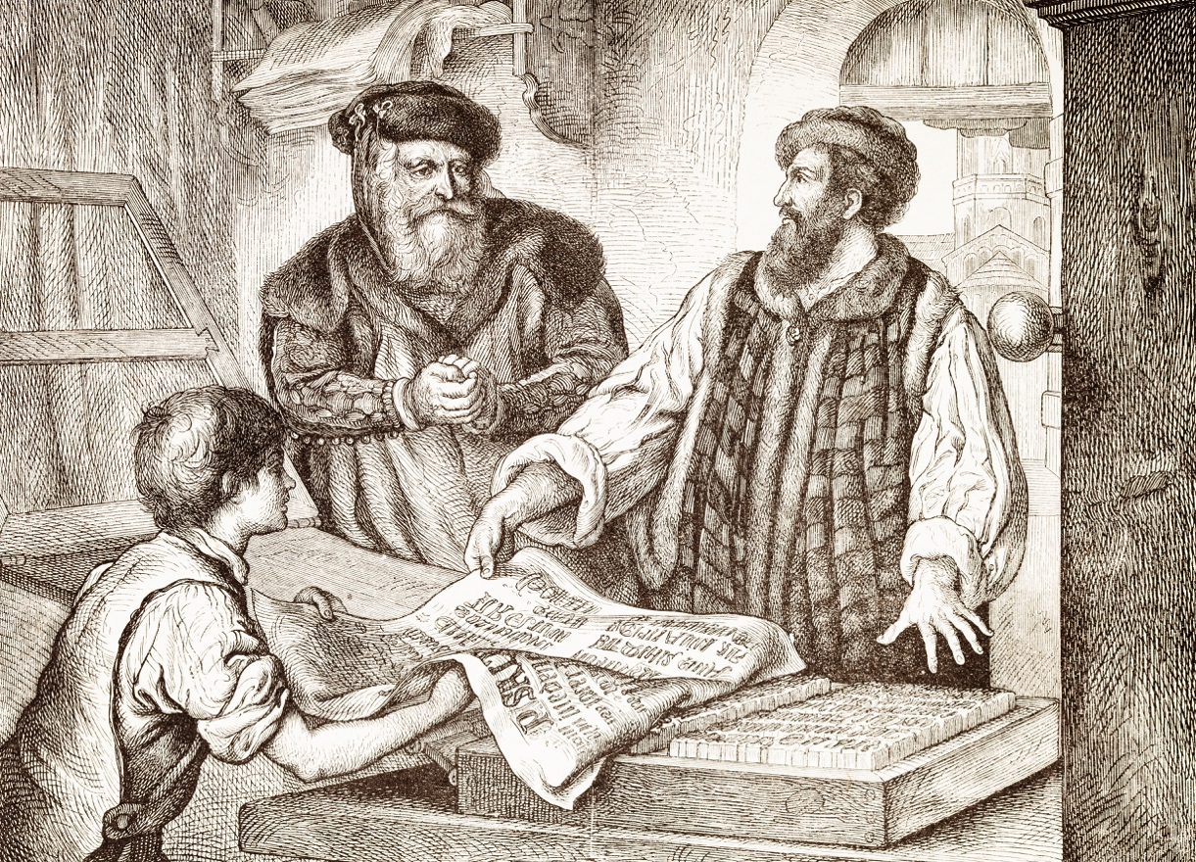
Engraving of publisher and printer John Gutenberg. © iStock / © Grafissimo.

Supporting Questions
- What was first printed?
- In what ways did the printing press preserve the past?
- How did the printing press stimulate interest in exploration?
- To what extent did the printing press facilitate change?

9th Grade Printing Press Inquiry

Did the Printing Press Preserve the Past or Invent the Future?
New York State Social Studies Framework Key Idea & Practices | 9.9 TRANSFORMATION OF WESTERN EUROPE AND RUSSIA: Western Europe and Russia transformed politically, economically, and culturally ca. 1400–1750. This transformation included state-building efforts, conflicts, shifts in power and authority, and new ways of understanding the world.  Gathering, Using, and Interpreting Evidence Chronological Reasoning and Causation
Staging the Compelling Question | Discuss the difficulties of spreading reliable information after playing a modified version of the “telephone” game using oral, handwritten, and typed information.

Supporting Question 1 |  | Supporting Question 2 |  | Supporting Question 3 |  | Supporting Question 4
What was first printed? |  | In what ways did the printing press preserve the past? |  | How did the printing press stimulate interest in exploration? |  | To what extent did the printing press facilitate change?
Formative  Performance Task |  | Formative  Performance Task |  | Formative  Performance Task |  | Formative  Performance Task
List and describe what the Gutenberg press first printed. |  | Write a paragraph describing the ways the printing press allowed Europeans to preserve thoughts and beliefs. |  | Write an explanation of how the printing press advertised, and thus encouraged, exploration. |  | Develop a claim supported by evidence about the extent to which the printing press facilitated change.
Featured Sources |  | Featured Sources |  | Featured Sources |  | Featured Sources
Source A: “Treasures in Full: Gutenberg Bible”  Source B: Excerpt from Man and Nature in the Renaissance  Source C: Excerpt from The Printing Press: Transforming Power of Technology |  | Source A: Excerpt from “Gutenberg and the Printing Revolution in Europe”  Source B: Map of the spread of printing  Source C: Excerpt from The History of Philosophy |  | Source A: Excerpt from American Colonies: The Settling of North America  Source B: Excerpt from a letter from Columbus to the Spanish royals  Source C: Map of diffusion of Columbus’s letter |  | Source A: Excerpt from The Printing Revolution in Early Modern Europe  Source B: Excerpt from Gutenberg: How One Man Remade the World with Words  Source C: Excerpt from “Information Technology and Economic Change”

Summative Performance Task | ARGUMENT Did the printing press preserve the past or invent the future? Construct an argument (e.g., detailed outline, poster, essay) that addresses the compelling question using specific claims and relevant evidence from historical sources while acknowledging competing views.
 | EXTENSION Read a Science article and debate whether the impact of social media on contemporary society is as great as or greater than the impact Gutenberg’s printing press had in the 15th century.
Taking Informed Action | UNDERSTAND Explore the resources available through Project Gutenberg.  ASSESS Determine the needs of your local school or community library.  ACT Create CD/DVD resources through Project Gutenberg’s CD/DVD Project to address the area of greatest need.

Overview

Inquiry Description
This inquiry leads students through an investigation of the impacts of the printing press by examining its utility in society, both as an instrument to preserve cultural products of the past and as an agent of change. By investigating the compelling question “Did the printing press preserve the past or invent the future?” students evaluate both functions of the printing press and consider which had the greater impact. The formative performance tasks build on knowledge and skills through the course of the inquiry and help students recognize the dual nature of the printing press in order to better understand its importance in larger historical phenomena. Students create an evidence-based argument about whether the printing press promoted continuity or change after considering the ways in which it preserved existing systems of belief and thought, enabled the dissemination of information, and led to increased exploration and systemic change within European societies.
In addition to the Key Idea listed earlier, this inquiry highlights the following Conceptual Understanding:
- (9.9a) The Renaissance was influenced by the diffusion of technology and ideas. The Islamic caliphates played an important role in this diffusion.
Note: This inquiry is expected to take four to six 40-minute class periods. The inquiry time frame could expand if teachers think their students need additional instructional experiences (i.e., supporting questions, formative performance tasks, and featured sources). Teachers are encouraged to adapt the inquiries​ in order to meet the needs and interests of their particular students. Resources can also be modified as necessary to meet individualized education programs (IEPs) or Section 504 Plans for students with disabilities.

Structure of the Inquiry
In addressing the compelling question “Did the printing press preserve the past or invent the future?” students work through a series of supporting questions, formative performance tasks, and featured sources in order to construct an argument with evidence while acknowledging competing perspectives.

Staging the Compelling Question
The compelling question could be staged by having students discuss the difficulties of spreading reliable information after playing a modified version of the telephone game using oral, handwritten, and typed information. First, students play a traditional game of telephone, sharing information orally. In the next round, students are asked to write/rewrite the information as they play the game. In the final round, students use typed information (e.g., text or typed messages) to communicate the ideas they hear. Students should discuss the variability in the different types of information transmission and should consider the potential long-term and short-term possibilities for communication and miscommunication.

Supporting Question 1
The first supporting question—“What was first printed?”—asks students to consider the earliest products printed by the Gutenberg press. This formative performance task asks students to list and describe those texts. Featured Source A looks specifically at the first three items mass-produced by Gutenberg’s team and elaborates on the role of the church in printing. In Featured Source B, an excerpt from Man and Nature in the Renaissance, Debus speaks to the role of the printing press in creating standard texts of classical philosophers, specifically those in Latin and Greek. Featured Source C, an excerpt from Crompton’s The Printing Press, discusses the initial public demand for the classics but explains that this effort eventually led to a demand for content in vernacular languages.

Supporting Question 2
The second supporting question—“In what ways did the printing press preserve the past?”—asks students to examine the ways in which the printing press allowed Europeans to create standard texts, specifically through the printing of classic works and religious tracts. For this formative performance task, students write a paragraph describing the ways in which the printing press allowed Europeans to preserve their thoughts and beliefs. Featured Source A, from the Constitutional Rights Foundation, speaks to the dissemination of information before and after the printing press. Featured Source B shows the expansion of the printing press throughout the 15th century in order to illustrate the growth and prevalence of the press-created texts. Featured Source C, an excerpt from Fieser’s The History of Philosophy, connects the growth of humanism to the use of the press to preserve Greek and Latin classics.

Supporting Question 3
The third supporting question—“How did the printing press stimulate interest in exploration?”—asks students to consider how the dissemination of information through the printing press affected people’s desire to explore the world outside Europe. For the third formative performance task, students use the featured sources to explain how promoters used the printing press to stimulate interest in exploration. Featured Source A explains the impact of the press on sharing (or not sharing) the accounts of various explorers’ exploits. Featured Source B provides some context for Columbus’s letter to the Spanish royals after his first voyage across the Atlantic. Featured Source C is a map illustrating the influence of Columbus’s letter as it spread across the continent. Collectively, these sources allow students to analyze the role the printing press played in the larger historical trend of increased exploration.

Supporting Question 4
The fourth supporting question—“To what extent did the printing press facilitate change?”—challenges students to consider how the printing press changed some aspects of European society and resulted in direct and indirect challenges to societal systems. The formative performance task asks students to write an evidence-based claim about the role of the printing press in enabling change to occur. In combination with the featured sources from the previous performance tasks, the featured sources for Supporting Question 4 present students with ways in which the printing press represented both continuity and change. In Featured Source A, Eisenstein argues that the preservation of the old became a means for revolutionary change. Featured Source B builds on this view by applying it to Martin Luther’s use of the printing press. And Featured Source C offers a connection between the printing press and economic change.

Summative Performance Task
At this point in the inquiry, students have been introduced to several ways in which the printing press preserved the past or led Europeans toward the future. Students should be able to demonstrate the breadth of their understanding and the ability to use evidence from multiple sources to support their claims. In this task, students are asked to construct an evidence-based argument responding to the compelling question “Did the printing press preserve the past or invent the future?”
Students’ arguments will likely vary but could include any of the following:
- Although the printing press spread new information, it was largely used as a means to preserve traditional systems and classical knowledge.
- The printing press was initially used as a means to preserve classical knowledge and traditional systems, but it also allowed for a systematic way to spread information and promote new ideas.
- The printing press allowed society to preserve documents that promoted traditional systems and classical knowledge, but doing so resulted in the reassessment of traditions and challenges to the status quo.
- The printing press allowed Europeans increased access to knowledge, old and new, the demand for which led to changes in societal structures and national priorities.
Students could extend these arguments by considering how access to and dissemination of information affects society. Students could read the featured source article from Science magazine and debate the idea that the growing influence of social media affects contemporary society to the same extent that Gutenberg’s printing press did in the 1400s.
Students have the opportunity to Take Informed Action by becoming active contributors in sharing knowledge and information using Project Gutenberg. Students demonstrate that they understand by exploring the various resources available through Project Gutenberg. They show their capacity to assess by determining the needs and/or disparities of resources in their local school or community library. And they show that they can act when they create resources to address the area of greatest need. (See http://www.gutenberg.org/wiki/Gutenberg:The_CD_and_DVD_Project.)

Supporting Question 1
Featured Source | Source A: The British Library, website describing the printing press, diffusion of literature, and examples of early prints, “Treasures in Full: The Gutenberg Bible,” no date

Gutenberg’s Texts
Gutenberg’s invention made it possible to mass-produce books. He himself did not make money out of it, but his method had great commercial potential and it became the basis of the success of many later printers and publishers.
Technology is not enough for success however. A publisher needs to choose the right texts for his market. This was much more important for a printer than for the men and women who made a living from producing manuscripts. A printer had to sell many copies of the same work at the same time, and he had to sell them fast to recover a substantial investment.
Gutenberg and his team were aware of this problem: all copies of the Bible had been sold even before printing was completed.
In the 50 years after Gutenberg began printing, printed books spread along the trade routes of Western Europe. Books did not become cheap immediately after the appearance of Gutenberg’s printed works, but prices soon began to fall. By 1500 access to books had changed profoundly. This meant more access to information, more dissent, more informed discussion and more widespread criticism of authorities. Europe and the world beyond would have been a very different place without Gutenberg’s invention.
© The British Library Board. http://www.bl.uk/treasures/gutenberg/gutenbergstexts.html.

1. The Bible
Gutenberg’s first and only large-scale printing enterprise was the Bible in Latin. This is not an obvious choice of text, for the Bible was not very central to the daily life of the Church in the 15th century.
Parts of the Bible would have been used in church every day, but not in the order in which they appear in the Bible. The texts of the Bible were reorganised in a Missal to suit the complicated order in which extracts were to be read. Missals were different from region to region, however. Perhaps Gutenberg realised that, in order for a large-scale printing project to be commercially successful, he had to aim at an international market. The Bible might sell fewer copies in each region, but it had the potential to sell all over Western Europe.
Gutenberg and his team also knew that they needed to market their new invention. In 1454 they showed their product to an international audience in Frankfurt, perhaps even before the project was completed. They must have been aware that a successful launch would be much easier if they began with a high-profile book of importance beyond their local area.
© The British Library Board. http://www.bl.uk/treasures/gutenberg/bible.html.

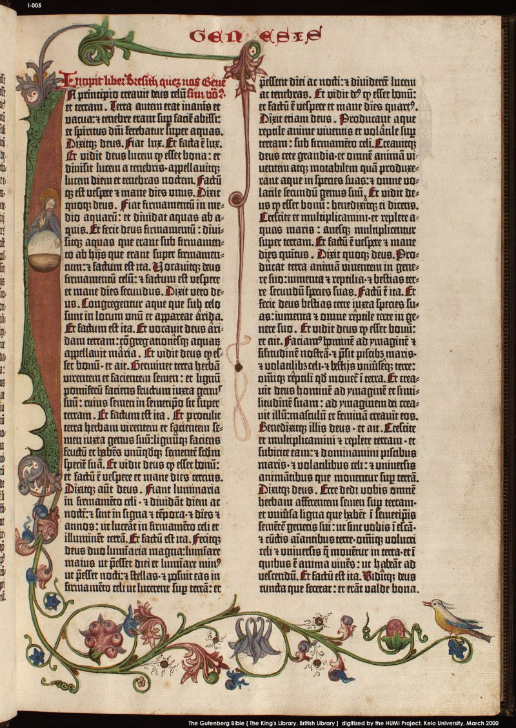
A page from the Book of Genesis in the Gutenberg Bible.
© The British Library Board.

2. Donatus’s Latin Grammar
In the 15th century, Latin was the language used by the educated and governing classes throughout Europe. The most widespread work used for teaching it, Ars minor (The Smaller Art [of Grammar]), was written in the 4th century by Aelius Donatus. He was the teacher of Jerome who translated the Bible from Hebrew and Greek into Latin.
Donatus’s Ars minor was one of the first items to be printed in Europe. There are many editions from the 15th century, but most survive only in fragments. Little books used by schoolboys, most have been worn to bits. Large and prestigious books such as the Bible have survived in much better condition, for they often ended up being owned by institutions with libraries where they were spared heavy use and they were protected from one generation to the next.
Quite a number of fragments survive of Donatus’s grammar printed with the same type as the Gutenberg Bible. The British Library has a copy of leaf 2 of one of these editions. It was previously dated around 1455, but the date now seems less certain, for it is of course possible that the type was used after the Bible was printed.
It is highly likely that some of the editions are earlier than the Gutenberg Bible, for it would have made sense to print a small schoolbook while preparing for a gigantic publication like the Bible. It would have brought in much needed ready cash.
© The British Library Board. http://www.bl.uk/treasures/gutenberg/donatus.html.

3. Indulgences
Indulgences were awarded by the Catholic Church as a remission of sin, earned either by prayer or, especially in the later Middle Ages, through a donation of money.
A letter of indulgence took the form of ready-made receipts leaving an empty space for the name of the purchaser, who was meant to take it to a father confessor as proof of having obtained the right to the forgiveness of sins.
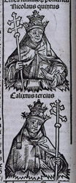
Nicholas V, from The Nuremberg Chronicle Nuremberg: Anton Koberger, 12 July 1493.
It now seems possible that Gutenberg printed indulgences as early as 1452, at the request of Nicolaus Cusanus, the prominent German cardinal—a very early connection between printing and the bureaucratic needs of the Church. But none of the indulgences which may have been printed in 1452 has survived.
On 12 April 1451, in order to assist the defence of Cyprus against a Turkish invasion, Pope Nicholas V granted to John II, King of Cyprus, the income raised from an indulgence. On 6 January 1452, John II appointed as his commissary Paulinus Zappe or Chappe, a Cypriot nobleman. The indulgence was valid between 1 May 1452 and 30 April 1455.
The British Library copy was sold at Neuss (near Düsseldorf) to Hinricus Mais, Pastor in Rosellen (near Neuss), his sister Greta Pinenkranss, and another of his female relatives, on 29 April 1455—the day before the permission to sell the indulgence expired.
It is printed on vellum, as are all surviving printed copies of the indulgence, and measures 157 x 235 mm. It was acquired by the Library in June 1845….

Sale of indulgences
For the printer, indulgences could have meant cash, paid for by the Church, much needed during or after a capital intensive venture. For the Church it meant a rationalisation of an otherwise labour-intensive bureaucratic procedure: thousands of identical letters of indulgence could be required at a single visit to a town. Compared with writing them out by hand, they could now be produced at much reduced cost. Printing provided an efficient solution to a bureaucratic problem.
We do not know how many copies of this indulgence were printed. By the end of the century, one indulgence was said to have been printed in as many as 142,950 copies.
The sale of indulgences in the Middle Ages was satirised by Chaucer in ‘The Pardoner’s Tale’, a pardoner being someone who sold indulgences.
© The British Library Board. http://www.bl.uk/treasures/gutenberg/indulgences.html.

Supporting Question 1
Featured Source | Source B: Allen George Debus, description of how the printing press allowed for the diffusion of knowledge, Man and Nature in the Renaissance (excerpt), 1978

Dedication to the ancients is a familiar characteristic of Renaissance humanism. The search for new classical texts was intense in the fifteenth century, and each new discovery was hailed as a major achievement.…
The search for new [classical] texts—and new translations—resulted in a new awareness of the importance of Greek.…
But Renaissance humanism cannot simply be reduced to the recovery of a pure Aristotle, Ptolemy, or Galen. No less influential on the development of modern science—and certainly part of the same humanistic movement—was the revival of…texts of late antiquity.…
Coincidentally, this search for the pure and original texts of antiquity occurred when a new means existed for disseminating this knowledge, the printing press. It is interesting that the earliest printed book from Western Europe dated from 1447, at the very beginning of our period. For the first time it became possible to produce standard texts for scholars at a moderate price. In the scientific and medical fields these incunabula [books] were for the most part printings of the old medieval scholastic texts.
Copyright © 1978. Cambridge University Press.

Supporting Question 1
Featured Source | Source C: Samuel Willard Crompton, description of how the printing press led to books being printed in European languages other than Latin, The Printing Press: Transforming Power of Technology (excerpts), 2003

[Latin’s] connection to the glorious days of the Roman Empire and its use in the classics written by such men as Cicero, Pliny, and Galen made it natural for elite Europeans to thrill to the Latin tongue, and for the first books to be printed in that language. But printing soon had a democratizing effect: Europeans began to want, even to demand, books printed in their own languages. This was the beginning of printing in the vernacular, or “native” language, meaning French, English, Spanish, German, and the like.
Printing began at Mainz, Germany, but it spread rapidly to other places. The printing press, which had taken so long to invent, was simple enough in its components that no one could patent or hold rights to it.…
All together, some 252 towns and cities recorded having a printing press by 1501. Three-quarters of these books were still printed in Latin; the heyday of the vernacular tongues was yet to come.
Copyright © 2003. Chelsea House.

Supporting Question 2
Featured Source | Source A: Constitutional Rights Foundation, description of how the printing press changed Europe, “Gutenberg and the Printing Revolution in Europe” (excerpts), Constitutional Rights Foundation, 2009

During the Middle Ages in Europe, most people lived in small, isolated villages. If people traveled at all, they typically ventured only a few miles from where they were born. For most people, the only source of both religious and worldly information was the village Catholic priest in the pulpit. News passed from one person to another, often in the form of rumor.
Written documents were rare and often doubted by the common people as forgeries. What counted in important matters was oral testimony based on oaths taken in the name of God to tell the truth.
Almost no one could read or write the language they spoke. Those few who were literate usually went on to master Latin, the universal language of scholarship, the law, and the Roman Catholic Church. Books, all hand-copied, were rare, expensive, and almost always in Latin. They were so valuable that universities chained them to reading tables. Most people passed their lifetime without ever gazing at a book, a calendar, a map, or written work of any sort.
Memory and memorization ruled daily life and learning. Poets, actors, and storytellers relied on rhyming lines to remember vast amounts of material. Craftsmen memorized the secrets of their trades to pass on orally to apprentices. Merchants kept their accounts in their heads.
Even scholars literate in Latin used memory devices to remember what they had learned. One device involved visualizing a building with various rooms and architectural features, each representing a different store of knowledge. A university scholar imagined walking through this virtual building along a certain pathway to recall the contents of entire books for his lectures.
Scribes, often monks living in monasteries, each labored for up to a year to copy a single book, usually in Latin. The scribes copied books on processed calfskin called vellum and later on paper.
Specialists or the scribes themselves “illuminated” (painted) large capital letters and the margins of many books with colorful designs and even miniature scenes. These books were beautiful works of art. But they took a long time to make and were very costly.…
By 1448, Gutenberg was back in Mainz. He borrowed money again to set up a printing workshop. In 1450, he printed his first book, a brief Latin grammar for students. He may have printed a few other things such as church “indulgences.” These standard forms often called for Christians to donate money to the Catholic Church. In exchange, the church forgave their sins, assuring admission into Heaven.
Gutenberg, however, had a much bigger project in mind. He knew that the Catholic Church wanted uniform Latin Bibles to standardize worship in Europe. Gutenberg could supply many identical copies of these Bibles by printing them. But he needed more money to set up a second print shop.…
Less than 50 years after Gutenberg printed the Bible, over 1,000 print shops had sprung up in more than 200 European cities and towns. They turned out more than 10 million copies of books in Latin and other European languages. Books became cheaper in price and available to anyone who could read them. Books were no longer chained in libraries.

The spread of knowledge, both factual and not, exploded throughout Europe. Books began to appear for the first time with the author’s name on a title page. This made writers responsible for the content of their books, thus improving their accuracy. It also gave rise to the first copyright laws, protecting authors from having others publish their works without permission.
By the 1400s, the Renaissance had already begun in Italy, and this cultural revival was spreading to other parts of Europe. Scholars wanted more copies of the recently rediscovered writings of Aristotle, St. Augustine, Cicero, and other ancient authors. The scribes, however, could not work fast enough to meet the demand.
Printing presses were soon producing great numbers of books translated into Latin from Greek, Hebrew, Arabic, and other classic languages. These books dealt with many subjects such as literature, the law, philosophy, architecture, and geography. By 1500, Renaissance Venice was Europe’s printing capital with 150 presses at work.
From the “Communication of Ideas” issue, Bill of Rights in Action 24, no. 4 (Winter 2009). © Constitutional Rights Foundation. http://www.crf-usa.org/bill-of-rights-in-action/bria-24-3-b-gutenberg-and-the-printing-revolution-in-europe.

Supporting Question 2
Featured Source | Source B: Map showing the spread of printing, “The Spread of Printing Before 1500”

The Spread of Printing Before 1500

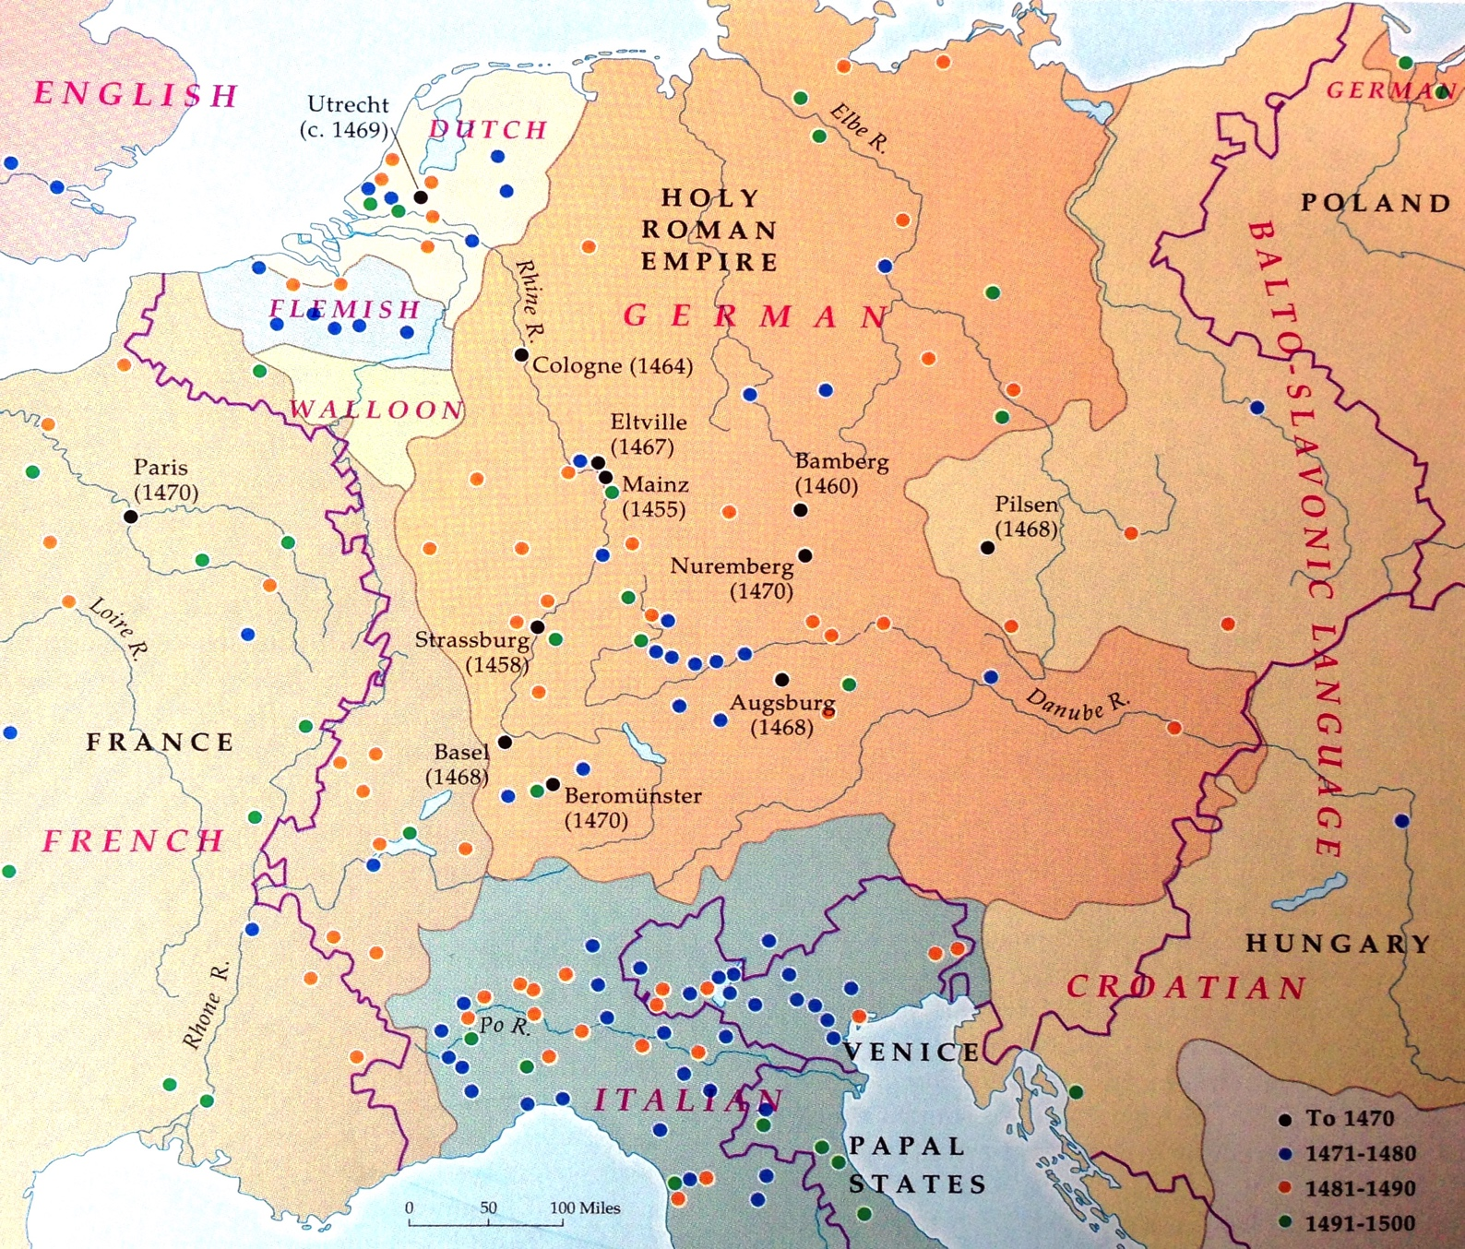

From Mortimer Chambers et al. The Western Experience. Vol. I, To the Eighteenth Century. 6th ed. Copyright © 1995. McGraw-Hill.

Supporting Question 2
Featured Source | Source C: James Fieser, description of humanism, “Renaissance and Early Modern Philosophy,” The History of Philosophy: A Short Survey (excerpt), 2008

One of the most distinctive intellectual movements within the Renaissance was humanism—which was originally called “humanities”, that is, the study of humanity. The main emphasis of humanism was secular education using Greek and Latin classics, rather than medieval sources. There were five traditional subjects in humanities education, namely, grammar, rhetoric, poetry, history, and moral philosophy. The most significant impact humanism had on philosophy was the revived study of ancient Greek philosophical schools thanks to the publication of new editions and translations of classical texts. The invention of the printing press during this time made these books much more readily available to readers, and the influence of classical philosophy spread like wildfire. Humanistic philosophers latched onto the earlier schools of Greek philosophy, almost as though they were pretending that the middle ages never existed. They variously associated themselves with Platonism, Aristotelianism, Epicureanism, Stoicism, or Skepticism, interpreting the classical texts and expanding on them.
Available at the University of Tennessee–Martin website. https://www.utm.edu/staff/jfieser/class/110/6-renaissance.htm.

Supporting Question 3
Featured Source | Source A: Alan Taylor, description of how the printing press shaped the Age of Exploration, American Colonies: The Settling of North America (excerpts), 2002

During the second half of the fifteenth century, the development of the printing press immensely lowered the cost and increased the volume of book publishing. More people learned to read, as books became available to more than the wealthy and leisured elite. By the end of the century, Europeans possessed twenty million copies of printed books. Readers especially delighted in vivid accounts of the wealth and power of India and China. These included the real travels of Marco Polo, an Italian merchant, as well as the pure fictions attributed to John de Mandeville. Inspired by their literary fantasies, European visionaries longed to reach the Far East to enlist their peoples and wealth for a climactic crusade against Islam.…
[Upon reaching the West Indies on his maiden voyage across the Atlantic,] Columbus unilaterally declared the natives subject to the Spanish crown. He reported, “I found very many islands filled with people innumerable, and of them all I have taken possession for their highnesses, by proclamation made and with the royal standard unfurled, and no opposition was offered to me.” Of course, not understanding a word of Spanish, the Indians failed to recognize any cue to oppose Columbus’s ceremony. As a further act of possession, he systematically renamed all of the islands to honor the Spanish royal family or the Christian holy days. Columbus even renamed himself, adopting the first name “Christoferens”—meaning “Christ-bearer,” testimony to his sense of divine image.
After his largest ship ran aground, Columbus decided immediately to start a colony by obliging thirty-nine crew members to remain on the island he called Hispaniola. They built a crude fort from the timbers of their wrecked ship. In the two remaining vessels Columbus sailed home, taking a roundabout route north and then east, to catch winds bound for Europe. He reached Spain in March 1493 to receive a hero’s welcome from King Ferdinand and Queen Isabella.
What happened next rendered Columbus’s voyage of enduring and global significance, far beyond the achievements of his Norse predecessors. The Norse discoveries proved a dead end because they remained largely unknown outside of the northwestern fringe of Scandinavia. Thanks to the newly invented printing press, word of Columbus’s voyage and discovery spread rapidly and widely through Europe. Eagerly read, his published report ran through nine editions in 1493 and twenty by 1500. Publication in multiplying print helped to ensure that Columbus’s voyages would lead to an accelerating spiral of further voyages meant to discern the bounds and exploit the peoples of the new lands.
Intrigued by Columbus’s glowing reports of the Indians’ gold jewelry and their supposed proximity to Asia, King Ferdinand and Queen Isabella promptly decided to send Columbus back with another, larger expedition of exploration and colonization.
From American Colonies by Alan Taylor, copyright © 2001 by Alan Taylor. Used by permission of Viking Books, an imprint of Penguin Publishing Group, a division of Penguin Random House LLC.

Supporting Question 3
Featured Source | Source B: Christopher Columbus, letter to Queen Isabella I and King Ferdinand II of Spain describing his first voyage (excerpts), 1493

NOTE: On August 3, 1492, Columbus set sail from Spain to find an all-water route to Asia. On October 12, more than two months later, Columbus landed on an island in the Bahamas that he called San Salvador; the natives called it Guanahani.
For nearly five months, Columbus explored the Caribbean, particularly the islands of Juana (Cuba) and Hispaniola (Santo Domingo), before returning to Spain. He left thirty-nine men to build a settlement called La Navidad in present-day Haiti. He also kidnapped several Native Americans (between ten and twenty-five) to take back to Spain—only eight survived. Columbus brought back small amounts of gold as well as native birds and plants to show the richness of the continent he believed to be India.
When Columbus arrived back in Spain on March 15, 1493, he immediately wrote a letter announcing his discoveries to King Ferdinand and Queen Isabella, who had helped finance his trip. The letter was written in Spanish and sent to Rome, where it was printed in Latin by Stephan Plannck. Plannck mistakenly left Queen Isabella’s name out of the pamphlet’s introduction but quickly realized his error and reprinted the pamphlet a few days later. The copy shown here is the second, corrected edition of the pamphlet.
The Latin printing of this letter announced the existence of the American continent throughout Europe. “I discovered many islands inhabited by numerous people. I took possession of all of them for our most fortunate King by making public proclamation and unfurling his standard, no one making any resistance,” Columbus wrote.
In addition to announcing his momentous discovery, Columbus’s letter also provides observations of the native people’s culture and lack of weapons, noting that “they are destitute of arms, which are entirely unknown to them, and for which they are not adapted; not on account of any bodily deformity, for they are well made, but because they are timid and full of terror.” Writing that the natives are “fearful and timid…guileless and honest,” Columbus declares that the land could easily be conquered by Spain, and the natives “might become Christians and inclined to love our King and Queen and Princes and all the people of Spain.”

I have determined to write you this letter to inform you of everything that has been done and discovered in this voyage of mine.
On the thirty-third day after leaving Cadiz I came into the Indian Sea, where I discovered many islands inhabited by numerous people. I took possession of all of them for our most fortunate King by making public proclamation and unfurling his standard, no one making any resistance. The island called Juana, as well as the others in its neighborhood, is exceedingly fertile. It has numerous harbors on all sides, very safe and wide, above comparison with any I have ever seen. Through it flow many very broad and health-giving rivers; and there are in it numerous very lofty mountains. All these island are very beautiful, and of quite different shapes; easy to be traversed, and full of the greatest variety of trees reaching to the stars.…
In the island, which I have said before was called Hispana, there are very lofty and beautiful mountains, great farms, groves and fields, most fertile both for cultivation and for pasturage, and well adapted for constructing buildings. The convenience of the harbors in this island, and the excellence of the rivers, in volume and salubrity, surpass human belief, unless [one] should see them. In it the trees, pasture-lands and fruits different much from those of Juana. Besides, this Hispana abounds in various kinds of species, gold and metals. The inhabitants … are all, as I said before, unprovided with any sort of iron, and they are destitute of arms, which are entirely unknown to them, and for which they are not adapted; not on account of any bodily deformity, for they are well made, but because they are timid and full of terror.…But when they see that they are safe, and all fear is banished, they are very guileless and honest, and very liberal of all they have. No one refuses the asker anything that he possesses; on the contrary they themselves invite us to ask for it. They manifest the greatest affection towards all of us, exchanging valuable things for trifles, content with the very least thing or nothing at all.…I gave them many beautiful and pleasing things, which I had brought with me, for no return whatever, in order to win their affection, and that they might become Christians and inclined to love our King and Queen and Princes and all the people of Spain; and that they might be eager to search for and gather and give to us what they abound in and we greatly need.
© Gilder Lehrman Institute of American History. http://www.gilderlehrman.org/history-by-era/exploration/resources/columbus-reports-his-first-voyage-1493.

Supporting Question 3
Featured Source | Source C: Matthew Edney, map and description of how Columbus’s letter spread across Europe, “Geographical Diffusion of Columbus's First Letter,” Osher Map Library: Smith Center for Cartographic Education, 1996

NOTE: Per the Osher Map Library, the map is no longer clickable.

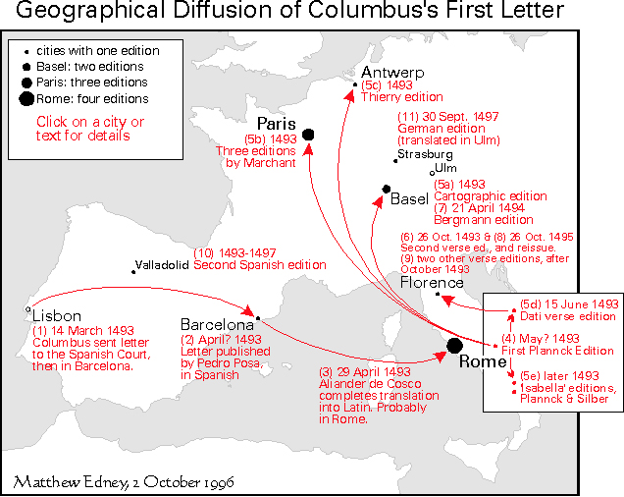

Christopher Columbus's 1493 announcement of the success of his voyage westward across the Atlantic Ocean quickly became one of the earliest ‘best sellers’ of European publishing. No less than eleven editions were published in 1493! They were issued across western Europe, in Spain, Italy, France, Switzerland, and the Netherlands. Six more editions were published in 1494–97. They are however all quite rare today; several of the editions survive in only a single copy; in total there are no more than 80 extant copies of all the editions.
This document traces the extremely rapid dissemination of the letter through its first 17 published editions. It is impossible to date all the editions precisely, but we can discern the basic pattern of the diffusion of this new knowledge to the major urban centers of western Europe.
Smith Center for Cartographic Education, University of Southern Maine. http://www.oshermaps.org/special-map-exhibits/columbus-letter/iv-diffusion-columbuss-letter-through-europe-1493-1497. This work is licensed under a Creative Commons Attribution-NonCommercial-ShareAlike 4.0 International License (http://creativecommons.org/licenses/by-nc-sa/4.0/).

Supporting Question 4
Featured Source | Source A: Elizabeth Eisenstein, description of how the printing press allowed for the preservation of historical works, The Printing Revolution in Early Modern Europe (excerpts), 2012

Permanence [of the printing press] introduced a new form of progressive change. The preservation of the old, in brief, was a prerequisite for a tradition of the new.
The advancement of learning had taken the form of a search for lost wisdom in the age of scribes. This search was rapidly propelled after printing. Ancient maps, charts, and texts once arranged and dated, however, turned out to be dated in more ways than one. Map publishers turned out genuinely new and improved editions of atlases and star maps, which showed that modern navigators and star gazers knew more things about the heavens and earth than did ancient sages. “The simple sailors of today,” wrote Jacques Cartier in his Brief Narration of 1545, “have learned the opposite of the philosophers by true experience.” New, improved editions of ancient texts also began to accumulate, uncovering more schools of ancient philosophy than had been dreamed of before. Scattered attacks on one authority by those who favored another provided ammunition for a wholesale assault on all received opinion.
Incompatible portions of inherited traditions could be sloughed off, partly because the tasks of preservation had become less urgent. Copying, memorizing, and transmitting absorbed fewer energies. Useful reference books were no longer blotted out or blurred with the passage of time. Cadence and rhyme, images and symbols ceased to fulfill their traditional function of preserving the collective memory. Once technical information could be conveyed directly by unambiguous numbers, diagrams, and maps, the esthetic experience became increasingly autonomous. Although books on the memory arts multiplied after printing, the need to rely on these arts decreased. Scribal systems, elaborated in print, ultimately petrified and are only now being reassembled, like fossil remains, by modern research.…
Nevertheless, scribal veneration for ancient learning lingered on long after the conditions that had fostered it had gone. Among Rosicrucians and Freemasons, for example, the belief persisted that the “new philosophy” was in fact very old. Descartes and Newton had merely retrieved the same magical key to nature’s secrets that had once been known to ancient pyramid builders but was later withheld from the laity or deliberately obscured by a deceitful priesthood.
Copyright © 2012. Cambridge University Press.

Supporting Question 4
Featured Source | Source B: John Man, description of how the printing press fueled the Protestant Reformation, Gutenberg: How One Man Remade the World with Words (excerpts), 2002

As Rome prepared its heavy artillery, Luther fired off more salvos, with the help of the press. His sermons, tracts and polemics, all in German the better to appeal to his audience, streamed from presses by the hundreds of thousands across the land, many with his portrait.…He became the focus of a propaganda war of which Mainz in 1460–62 had been a tiny precedent, and a publishing phenomenon, unrivalled anywhere, ever….According to one estimate, a third of all books printed in Germany between 1518 and 1525 were by him. Pause to consider that figure. Of course, printing was in its infancy, but Germany at the time was turning out about a million books a year, of which a third—300,000—were by Luther. No comparison with the modern world stands up.…
Of his thunderous outpourings, perhaps the most powerful was his Address to the Christian nobility of the German Nation, a sort of Reformation manifesto. His conclusion, in German of course, was virtually a call to arms. Every Christian leader had a duty to reform the Church.…
In three weeks it sold 4,000 copies—in Wittenberg alone, where the printers became rich. In the next two years it went through thirteen editions, with pirated versions appearing in Leipzig, Strasbourg and Basel. German princes heard and took note.
Copyright ©2002. John Wiley and Sons.

Supporting Question 4
Featured Source | Source C: Jeremiah Dittmar, article about the economic shifts that resulted from the printing press, “Information Technology and Economic Change” (excerpts), 2011

Between 1500 and 1600, European cities where printing presses were established in the 1400s grew 60% faster than otherwise similar cities. Cities that adopted printing in the 1400s had no prior advantage, and the association between adoption and subsequent growth was not due to printers choosing auspicious locations….

The printing press fostered knowledge and skills that were valuable in commerce. Print media played a key role in the development of numeracy, the emergence of business education, and the adoption of innovations in bookkeeping and accounting. With access to cheap waterborne transport, port cities were positioned to profit from innovations in commercial practice….

Among economic historians, there is some difference of opinion about the extent to which the movable type printing press was a revolutionary innovation. Mokyr (2005) notes that innovation depends on the cost of accessing existing knowledge, and that the printing press was one of the most important access cost– reducing inventions in history. Jones (1981) also argues that “western progress owed much to the superior means of storing and disseminating information.” Baten and van Zanden (2008) find a significant association between simulated national-level wages and observed differences in aggregate book production in European history. However, Clark (2001) finds no evidence of aggregate productivity growth associated with the diffusion of movable type printing. Mokyr (2005) similarly argues that the aggregate effects were small.

Social historians have hailed the movable type printing press as a revolutionary innovation. Braudel (1979a) identifies printing as one of three great technological revolutions observed 1400– 1800 (alongside advances in artillery and navigation). Gilmore (1952) states that printing drove “the most radical transformation in the conditions of intellectual life in the history of western civilization.” Eisenstein (1979) argues that printing created revolutionary new possibilities for “combinatory intellectual activity.” Roberts (1996) suggests the outcome was one “dwarfing in scale anything which had occurred since the invention of writing.”

Historically, urban death rates exceeded urban birth rates and migration drove city growth. Cities drew migrants to the extent that they offered relatively high wages, cultural amenities, and economic opportunities. In the pre-industrial era, commerce was a more important source of urban wealth and income than tradable industrial production. As a result, migration and city growth were typically contingent on commercial success.
Print media played a key role in the acquisition and development of skills that were valuable to merchants. The ability to calculate interest rates, profit shares, and exchange rates was associated with high returns for merchants engaged in large scale and long-distance trade. Starting in the 1480s, European presses produced a stream of “commercial arithmetics.” Commercial arithmetics were the first printed mathematics textbooks and were designed for students preparing for careers in business. They transmitted commercial know-how and quantitative skills by working students through problems concerned with determining payments for goods, currency conversions, interest payments, and profit shares….

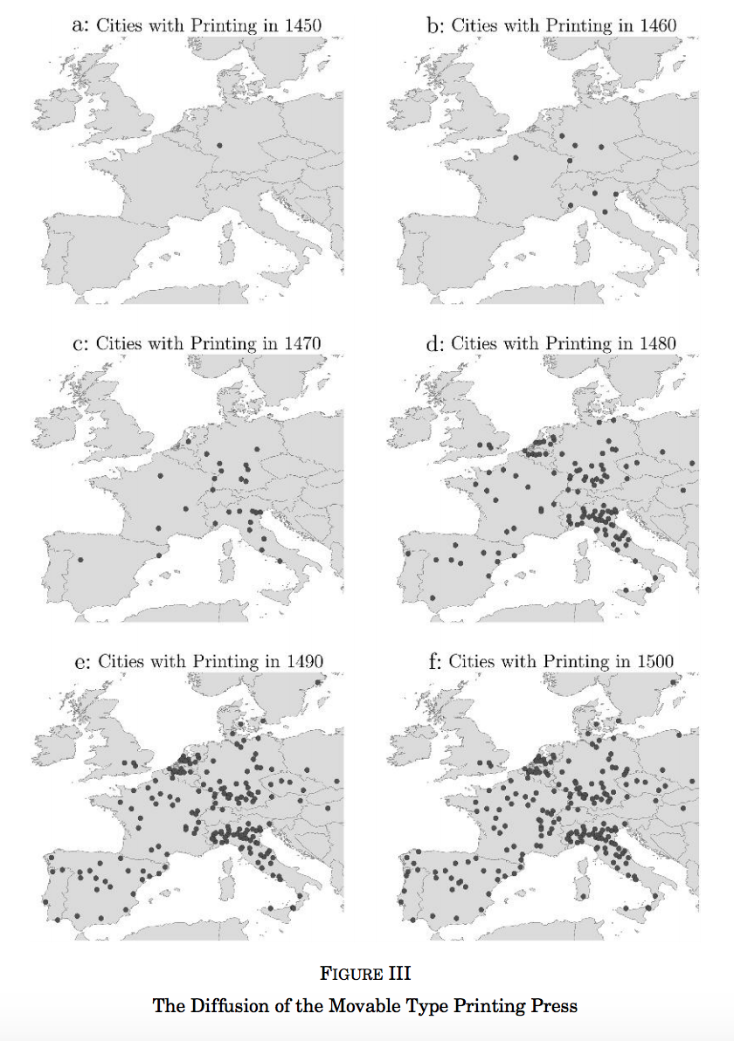

The availability of inexpensive texts was a key prerequisite for the spread of literacy in Renaissance Europe (Grendler 1990). School books generated high returns for Renaissance printers (Bolgar 1962; Nicholas 2003; Fussel 2005). Schooling in languages became part of a progression in which pupils went from “arts to marts.” Cities began to run schools for children who were not going to learn Latin—using printed grammar school texts. In the fifteenth century, it became expected that the children of the bourgeoisie would attend school (Bolgar 1962). But print media also promoted opportunities for the less privileged to obtain education and raise their incomes. Brady (2009) observes that no document better captures the new opportunities than Thomas Platter’s (1499–1582) autobiography (Platter1839). After wandering penniless across Europe, Platter began his formal schooling at age 18. Having learned Latin, Platter took a job as a rope maker in Zurich to support his book-buying and reading habit, taught himself Hebrew and Greek, and rose to become a wealthy school master, professor, and printer.

Jeremiah Dittmar, “Information Technology and Economic Change,” The Quarterly Journal of Economics (2011) 126 (3):1133-1172 by permission of Oxford University Press.

Summative Performance Task/Extension/E
Featured Source | Source A: Greg Miller, description of Twitter’s impact on human communication, “Social Scientists Wade into the Tweet Stream,” Science, September 29, 2011

Social Scientists Wade into the Tweet Stream
Depending on your perspective, Twitter is a great way to promote a product, keep up with far-flung friends and colleagues, connect with others who share your passion for Korean boy bands, or maybe even start a revolution. The 5-year-old social media Web site now claims that more than 100 million users post 230 million “tweets” (text messages up to 140 characters long) every day. In that torrent of data, some social scientists see an unprecedented opportunity to study human communication and social networks.
“Human interactions are what social scientists are really all about,” says Michael Macy, a sociologist at Cornell University. But observing large numbers of spontaneous interactions, which are often fleeting and private, has been an obstacle, Macy says. Until now. “Human beings around the globe are now communicating with each other using devices that record those interactions and have open access,” Macy says. “I think this is an extraordinarily exciting moment in the behavioral and social sciences.”
On page 1878, Macy and his graduate student Scott Golder report their effort to use Twitter to study the collective moods of millions of people in diverse cultures around the world in real time. Others have been using Twitter and other social media to investigate how information and persuasion propagate in social networks and to study political campaigns and movements, including the recent uprisings in North Africa.
Golder and Macy used a freely available protocol provided by Twitter to download more than 500 million tweets originating from 84 countries between February 2008 and January 2010. They searched these messages for roughly 1000 words on a tried-and tested list of words associated with positive (agree, fantastic, super) and negative (afraid, mad, panic) emotion.
Their findings paint a portrait of humanity’s mood swings. Positive emotion runs high in the morning, declines throughout the day, and rebounds in the evening. The same pattern occurs on the weekends, suggesting it’s not just work bringing people down, Golder notes. People are happier overall on weekends, but the morning peak in good vibes is delayed by a couple of hours, suggesting they sleep in. Across the seasons, positive emotion increased from late December to late June as the days got longer and decreased during the other half of the year, lending support to other research suggesting that it’s the change in day length rather than the absolute day length that determines seasonal mood swings.
Macy finds it remarkable that these patterns were similar across such distinct cultures and regions, once time zones and latitude were accounted for. Overall, the findings suggest that sleep and the biological clock exert a powerful influence on mood, Macy says. He and Golder acknowledge that that’s not a new idea, but they note that much of the previous research has been done on college undergraduates, hardly a group that represents the general population when it comes to sleep habits.
Using Twitter to track the mood of nations is analogous to using satellites to track the atmosphere, says Peter Dodds, an applied mathematician at the University of Vermont in Burlington. Dodds concedes that remote sensing of human happiness “sounds a bit Orwellian,” but he says his group has a greater good in mind: developing a measure of a society’s well-being that policymakers could use in parallel with economic indicators such as gross domestic product. In one recent study (available at http://arxiv.org/abs/1101.5120), Dodds, Christopher Danforth of Vermont, and colleagues examined 4.6 billion tweets over nearly 3 years. They paid people registered with Amazon’s Mechanical Turk service to rank the emotion evoked by more than 10,000 common words on a nine-point happy face to sad face scale. Analyzing the frequency with which these words occurred in their massive database of tweets, Dodds and colleagues found several patterns reported by Golder and Macy, including happy weekends and a morning peak in mood followed by an afternoon decline—“the daily unraveling of the human mind,” Dodds calls it. The team also examined outlier days: Not surprisingly, unusually “happy” days often coincided with holidays, whereas especially unhappy days tended to coincide with unexpected events, such as the Japanese earthquake and tsunami (see figure). Their findings also hint at a global decline in mood starting in April 2009 that continues at least through the first half of 2011.
Both studies illustrate the power of social media for studying social phenomena on a huge scale, says Duncan Watts, a sociologist at Yahoo! Research in New York City.
Watts says it is reassuring that the results generally fit with our intuitions. “It’s hard to imagine a result that we could get from these data that we wouldn’t subsequently be able to reconcile with what we already know about life,” he says. “If your standard for datadriven social science is that it deliver deeply counter intuitive yet still believable results, I’m not sure that’s possible.”
Watts and others think that social media could help break new ground in resolving questions about how information and influence flow through social networks. One example involves the idea of social contagion. In recent years, a string of high-profile papers has suggested that everything from smoking habits to obesity to happiness can spread through social networks from one person to another like a virus (Science, 23 January 2009, p. 454). But critics have argued that these studies can’t rule out alternative explanations, such as homophily, the birds-of-afeather effect whereby people with similar inclinations tend to associate with one another.
In a 2009 study in the Proceedings of the National Academy of Sciences, Sinan Aral and colleagues at New York University tackled social contagion in the context of people adopting a new product, in this case a mobile phone application developed by Yahoo! Over the course of the study, roughly 500,000 of the 27 million users of Yahoo!’s instant messaging service adopted the app. Using anonymized data provided by Yahoo! about individual users’ demographics, mobile phone usage, the types of Web sites they visited most frequently (sports, news, etc.), and their links to other users, the researchers developed statistical tools to estimate the relative influences of social contagion and homophily in the app’s spread. Having data on such a large number of people and their second-by-second interactions enabled a more sophisticated analysis than traditional methods would have, Aral says. And it pointed to a diminished role for social contagion: “Half of what we thought was peer influence was really just homophily and other confounding factors,” Aral says.
More recently, his team tried to manipulate social contagion in a randomized trial of viral-marketing features in a group of 10,000 Facebook users. Building features into a new app that allow new users to invite some or all or their Facebook friends to get the app can increase social contagion by up to 400%, the researchers report this month in Management Science.
Other researchers have used social media to study the spread of influence and ideas in the political domain. At Indiana University, Bloomington, Filippo Menczer and colleagues have been using Twitter to study devious campaign tactics and political polarization. During the 2010 election season, they developed an automated system for detecting underhanded campaign tactics on Twitter, such as “astroturf ” movements, concerted attempts by an organization or individual to create the appearance of a grassroots movement to support a candidate or spread rumors about an opponent.
They named it Truthy, inspired by comedian Stephen Colbert’s popularization of the word “truthiness” to describe things people feel or wish to be true regardless of the facts. The pattern of Twitter activity generated by an astroturf movement differs from more spontaneous Twitter traffic, Menczer says, and Truthy uses machine-learning algorithms to tell the difference. “Just looking at the structure of the network and how the information propagates, we have information about the nature of the message,” Menczer says.
Menczer and colleagues have extended this work to try to classify people’s political leanings based on their Twitter network. It’s surprisingly easy, Menczer says. Right-leaning users have a strong tendency to “retweet,” or propagate, only messages sent by other right-leaning users, and the same goes for those on the left (see figure, above), the researchers reported earlier this year at the Fifth International
AAAI Conference on Weblogs and Social Media. The findings don’t resolve whether Twitter simply reflects the polarization of American society or actually contributes to it, Menczer says. “Is the fact that these tools make it so easy for us to select our social contacts having a negative effect on our political discourse? This is an important question.” He admits it won’t be easy to answer. The influence of Twitter has also been a hot topic in light of the recent uprisings in
Egypt, Libya, and elsewhere in North Africa, which are among the first historical events to be chronicled in real time by ordinary citizens. Key questions include the extent to which Twitter has played a role in the coordination and spread of these events, as well as whether Twitter traffic could be used to predict events on the ground before they happen.
One of the largest repositories of Arabic-language tweets is a database started by Laila Shereen Sakr, an Egyptian-born graduate student in cinematic arts at the University of Southern California in Los Angeles. Shereen Sakr says the project originally sprang from an activist impulse to make sure the voices of Arabic speakers were heard. But she’s grown increasingly interested in the research potential. She’s found intriguing spikes in certain hashtags, the terms used to flag a topic on Twitter, preceding the fall of Zawiya and Tripoli in Libya, for example. Shereen Sakr hopes the project’s Web site (www.r-shief.org) will become a hub for researchers. “I would love for people in other disciplines to take this data and make something of it,” she says.
Indeed, making sense of the deluge of data from Twitter and other social media will require researchers to employ an interdisciplinary skill set that draws from traditional social sciences, statistics, and computer science (Science, 6 February 2009, p. 721). Although some traditionally trained social scientists remain skeptical about whether anything “serious” can be learned from social media and question whether those who use it are representative of the population as a whole, others insist the rewards could be rich. “There was this intriguing paradox where for most of the 20th century we seemed to know more about exploding stars at the edge of the galaxy and the proteome of yeast than we knew about how large human social groups function,” says Jon Kleinberg, a computer scientist at Cornell. But the digital detritus of 21st century life online may change all that, Kleinberg says: “Interesting things happen when you can take what was once invisible and make it visible.”
Reprinted with permission from AAAS. http://www.sciencemag.org.ezproxy.uky.edu/content/333/6051/1814.full.pdf

